HydroFlora: Autonomous Urban Hydroponic Farming System

Project Overview
HydroFlora is an innovative IoT-enabled urban agriculture system designed to optimize hydroponic crop production in limited urban spaces.
The system integrates IoT sensors, cloud computing, and artificial intelligence to monitor environmental conditions, detect anomalies, and maintain optimal plant growth with minimal human intervention.
HydroFlora addresses key global challenges such as:
- Urban food security
- Water efficiency in agriculture
- Autonomous farming systems
- Sustainable food production in cities
The system operates as a closed-loop hydroponic ecosystem capable of monitoring water quality, environmental conditions, and system health in real time.

Key Features

Autonomous Environmental Monitoring
Continuous monitoring of hydroponic parameters such as:
- pH
- TDS (Total Dissolved Solids)
- Water level
- Temperature
- Humidity
- Water temperature
- NPK
- Dissolved Oxygen Sensor
- CO2 level
- EC

Closed-Loop Water Recycling
A sustainable water management system that reduces waste by recycling and regulating the hydroponic nutrient solution.

Intelligent Monitoring Dashboard
A web-based dashboard providing real-time visualization of system parameters and alerts.

Cloud-Based Data Processing
Sensor data is transmitted to Huawei Cloud using MQTT for storage, monitoring, and processing.

AI-Based Anomaly Detection
Machine learning models implemented with Huawei MindSpore detect abnormal sensor readings and system malfunctions.

Rule-Based Plant Health Monitoring
Agronomic rules evaluate hydroponic conditions and provide recommendations when corrective actions are required.

System Architecture
HydroFlora follows a three-layer IoT architecture.

Perception Layer (Edge Layer)
Edge devices based on ESP32 microcontrollers collect environmental data using sensors such as:
- pH sensor
- TDS sensor
- Temperature sensor
- Humidity sensor
- Water level sensors
- Dissolved Oxygen Sensor
- NPK sensor
- EC sensor
- CO2 sensor
These devices perform initial sensing and transmit data to the cloud.

Network Layer

Sensor data is transmitted using the MQTT protocol, enabling lightweight and efficient communication between IoT devices and the cloud infrastructure.

c) Application Layer
The application layer includes:
- A web-based monitoring dashboard
- An AI anomaly detection engine
- A plant health evaluation system
Users can monitor hydroponic system conditions and receive alerts in real time.

AI Integration
HydroFlora integrates artificial intelligence to enhance monitoring and decision-making.
The AI component is implemented using Huawei MindSpore and trained using Huawei ModelArts.

AI Tasks
The AI system performs:
- Sensor anomaly detection
- Detection of abnormal environmental patterns
- Early warning of system failures
Example anomalies detected by the AI model include:
- unrealistic sensor values
- abnormal pH fluctuations
- incorrect humidity readings
- sensor malfunction patterns

Rule-Based Plant Health Evaluation
In addition to the AI anomaly detection system, HydroFlora includes a rule-based decision engine that evaluates plant health conditions based on known agronomic thresholds.
This hybrid approach combines AI-based monitoring with domain-specific rules, improving reliability and interpretability.

AI System Workflow
Hydroponic Sensors
(pH, TDS, temperature, humidity)
↓
ESP32 IoT Edge Device
↓
MQTT Data Transmission
↓
FastAPI AI Server
(api_model.py)
↓
Anomaly Detection Model
↓
↓
Rule-Based Plant Health Evaluation
↓
HydroFlora Dashboard
↓
Alerts and System Recommendations

Technologies Used

Hardware
- ESP32 Microcontrollers
- Hydroponic sensors (pH, temperature, humidity, water level)

IoT Technologies
- MQTT protocol
- IoT sensor nodes

Cloud Platform
- Huawei Cloud
- Huawei ModelArts

Software & AI
- Python
- MindSpore
- Pandas
- NumPy
- Jupyter Notebook

Frontend
- HTML
- CSS
- JavaScript

Project Structure
HydroFlora
│
├── ai_server
│ └── complete_model_implementation.py # FastAPI AI prediction server
│ └── mindspore_hydroponic_model.ckpt
│ └── mindspore_hydroponic_training_model.ipynb
│
├── assets
├── img
├── pages
├── vendor
│
├── dataset
│ └── IoTData--Raw--.csv
│
├── index.html # Main dashboard page
│
└── README.md

Installation and Setup

Prequisites
- Arduino IDE (for ESP32 firmware)
- Python 3.8+
- Huawei Cloud account with ModelArts enabled

Running the Application
- Clone the project repository.
- Create a Python Virtual Environment (Recommended)
      - python3 -m venv venv
      - venv\Scripts\activate
- Install required Python libraries
pip install numpy pandas mindspore joblib scikit-learn fastapi uvicorn
- Start the AI Server (FastAPI)
      - cd ai_server
      - uvicorn complete_model_implementation:app --reload --host 0.0.0.0 --port 8000
      - Open the automatic FastAPI documentation: http://127.0.0.1:8000/docs
5. Launch the HydroFlora Dashboard
      - Open index.html

10. Hydroponic IoT Sensor Dataset

Dataset Overview
The Hydroponic IoT Sensor Dataset contains time-series telemetry data collected from a small-scale hydroponic monitoring system.
The dataset includes environmental measurements and actuator states responsible for maintaining optimal hydroponic conditions.

Dataset Details
File: IoTData--Raw--.csv
Total records: 50,570
Number of features: 13
Data type: Raw time-series telemetry
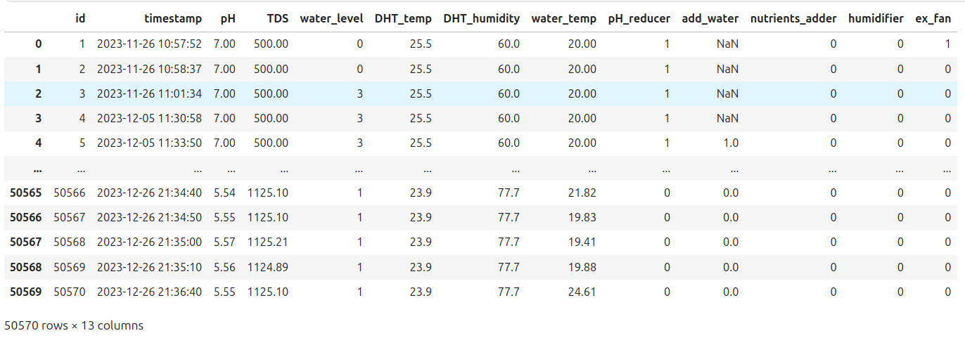
Reference: https://www.kaggle.com/datasets/itsmonir31/hydroponics-datasets

Dataset Structure
Column | Description
id | Record identifier
timestamp | Timestamp of measurement
pH | Nutrient solution acidity
TDS | Total dissolved solids concentration
water_level | Reservoir water level
DHT_temp | Ambient air temperature
DHT_humidity | Relative humidity
water_temp | Nutrient solution temperature
pH_reducer | Acid dosing pump state
add_water | Water refill pump state
nutrients_adder | Nutrient dosing pump state
humidifier | Humidifier state
ex_fan | Exhaust fan state

Dataset Collection Context
The data were collected using an Arduino/ESP-based IoT monitoring system connected to multiple environmental sensors.
The system records:
- water chemistry parameters
- environmental conditions
- actuator activation events
Collection period: 26 November 2023 – 26 December 2023
Sampling frequency: Irregular (event-driven logging)

Basic Statistics
Example statistics from the dataset:
pH
Mean ≈ 6.00
Range: 0.27 – 11.57
TDS
Mean ≈ 1154 ppm
Range: -283 – 2278 ppm
Temperature
Mean ≈ 24.32 °C
Humidity
Mean ≈ 71.71 %

Actuator Activation Frequency
Actuator | ON Events
pH reducer | 652
add water | 2260
nutrients adder | 3057
humidifier | 2458
exhaust fan | 52
These values show that actuator activations are relatively sparse compared to the number of sensor readings.

11.Future Improvements
Possible future enhancements include:
- reinforcement learning for automated nutrient optimization
- integration with mobile applications
- large-scale deployment across multiple rooftops
- additional environmental sensing capabilities

12.Contributors
Project developed by: Team EchoGuardians

